**Ideation Phase**

**Define the Problem Statements**

|  |  |
| --- | --- |
| Date | 19 September 2022 |
| Team ID | PNT2022TMID26285 |
| Project Name | AI- Based Localization And Classification Of Skin Disease With Erythema |
| Maximum Marks | 2 Marks |

**Customer Problem Statement Template:**

Create a problem statement to understand your customer's point of view. The Customer Problem Statement template helps you focus on what matters to create experiences people will love.

A well-articulated customer problem statement allows you and your team to find the ideal solution for the challenges your customers face. Throughout the process, you’ll also be able to empathize with your customers, which helps you better understand how they perceive your product or service.

**Example:**

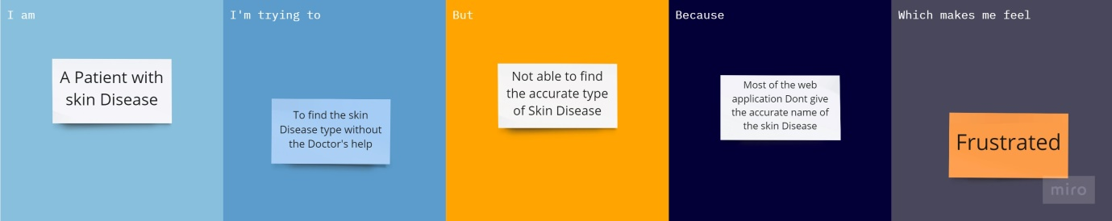

|  |  |  |  |  |  |
| --- | --- | --- | --- | --- | --- |
| **Problem Statement (PS)** | **I am (Customer)** | **I’m trying to** | **But** | **Because** | **Which makes me feel** |
| PS-1 | Patient with skin Disease | To find the type of disease | Not able to find the accurate type of my disease | Most of web application don’t have a good prediction | Frustrated |
| PS-2 | Family or a friend of the patient with skin Disease | To easily find about the disease the patient have without or before the consultation of the Doctor. | But it always fails without the help of the Doctor | Because most of the apps or web application is poor in predicting the disease | Irritated |